Tutorial 1

1. Request two numbers from the user and print the multiplication of the numbers.

IPO
Input : num1 and num2
Process : Multiply num1 * num2
Output : result

Pseudocode
1. Start
2. Input num1
3. Input num2
4. Result = num1 * num2
5. Print Result
6. End

Flowcart
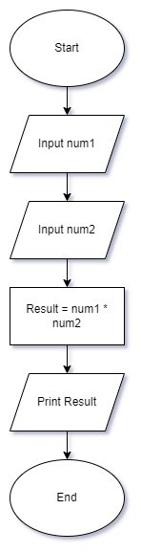

2. Determine whether a random number is greater than 50.

IPO
Input : Generate a random number.
Process: Compare it with 50.
Output : 'Yes' or 'No'.

Pseudocode
1. Start
2. Generate randomNum
3. If randomNum > 50, then
4. Print "Yes"
5. Else
6. Print "No"
7. End

Flowchart
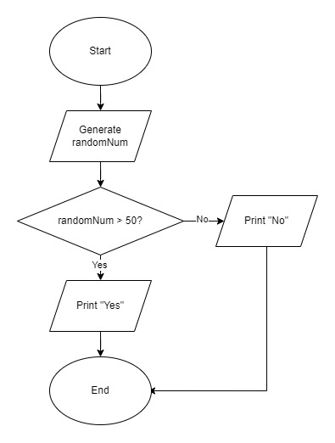

3. Print the pass/fail grade based on the mark entered by the user.

IPO
Input : mark
Process: Compare mark with 40
Output : ‘Pass’ or ‘Fail’

Pseudocode
1. Start
2. Input mark
3. If mark >= 40, then
4. Print "Pass"
5. Else
6. Print "Fail"
7. End

Flowchart
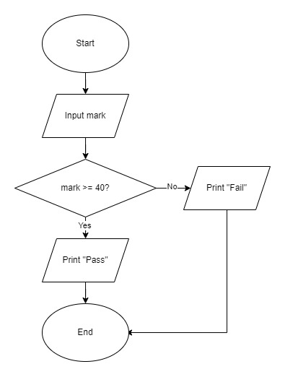

4. Print the Results of a Two-Player Dice Game.

IPO
Input: Generate random dice rolls for two players, dice1 and dice2
Process: Compare value of dice1 and dice2
Output: ‘Player1 win’ or ‘Player2 win’ or ‘Tie’

Pseudocode
1. Start
2. Generate random number from 1 to 6 for player1_dice
3. Generate random number from 1 to 6 for player2_dice
4. If player1_dice > player2_dice, then
5. Print "Player 1 wins"
6. Else if player2_dice > player1_dice, then
7. Print "Player 2 wins"
8. Else
9. Print "Tie!"
10. End

Flowchart
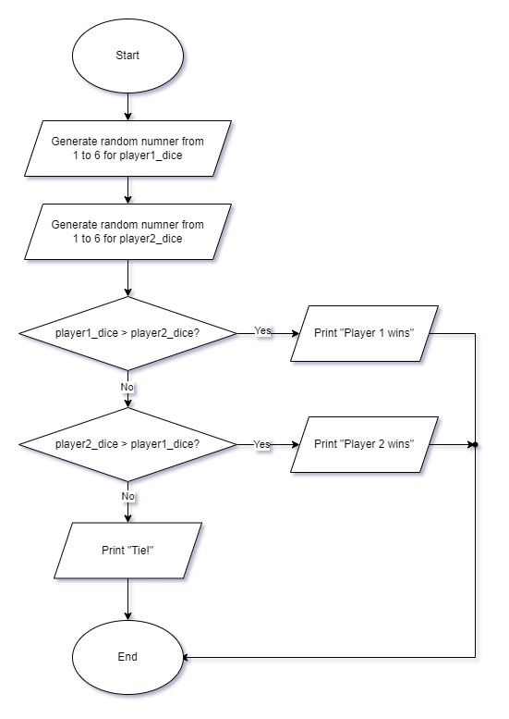

5. Print the Perimeter of a Rectangle.

IPO
Input: length, width
Process: Calculate 2*(length + width)
Output: perimeter.

Pseudocode
1. Start
2. Input length
3. Input width
4. Perimeter = 2*(length + width)
5. Print Perimeter
6. End

Flowchart
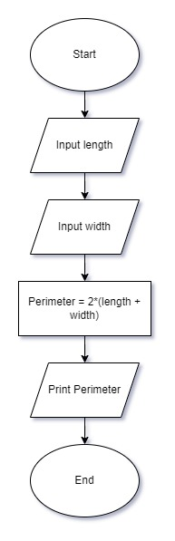

6. Print the Minimum Number from 10 Random Numbers.

IPO
Input: Generate 10 random numbers
Process: Find min among 10 numbers
Output: min

Pseudocode
1. Start
2. Generate ten random numbers
3. Set MinNum = First random number
4. For each random number in the list:
5. If the random number < MinNum, then
6. Set MinNum = the random number
7. Print MinNum
8. End

Flowchart
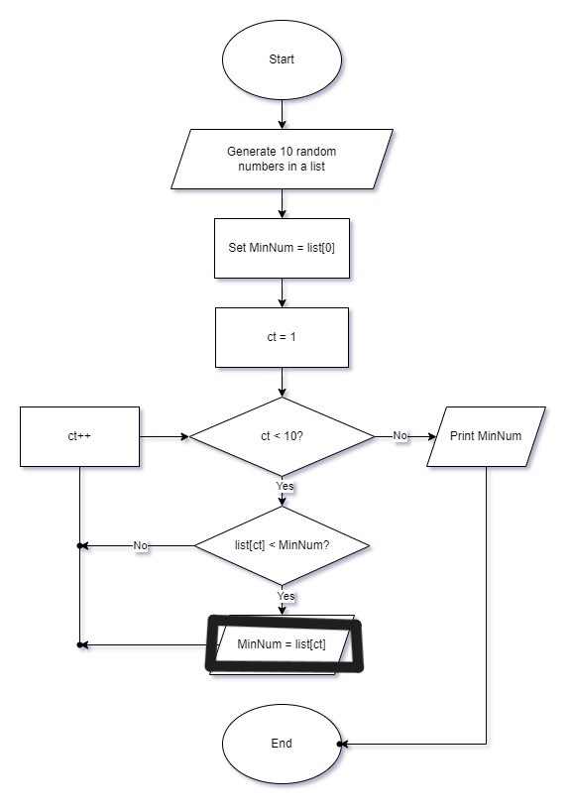

7. Print the Number of Odd and Even Numbers.

IPO
Input: Generate 10 random numbers between 10–100
Process: Count odd and even
Output: odd, even

Pseudocode
1. Start
2. Initialise OddCount = 0, EvenCount = 0
3. Generate ten random numbers in the range 10 to 100
4. For each random number:
5. If the random number % 2 == 1:
6. OddCount++
7. Else:
8. EvenCount++
9. Print "Odd Count: " + OddCount
10. Print "Even Count: " + EvenCount
11. End
Flowchart
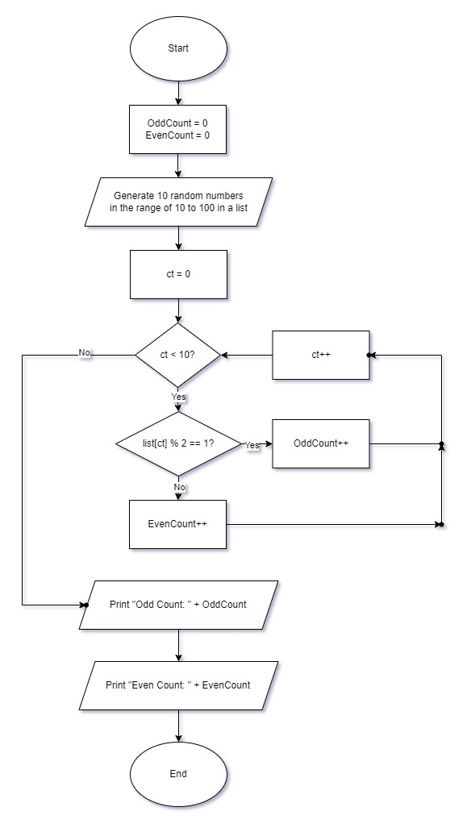

8. Count the Number of Alphabet U and M in a Sentence.

IPO
Input: sentence
Process: Count occurrences of 'U' and 'M'.
Output: number of ‘U’ and ‘M’

Pseudocode
1. Start
2. Input sentence
3. Initialise CountU = 0, CountM = 0
4. For each character in sentence:
5. If character == 'U':
6. CountU++
7. Else if character == 'M':
8. CountM++
9. Print "Count of 'U': " + CountU
10. Print "Count of 'M': " + CountM
11. End

Flowchart
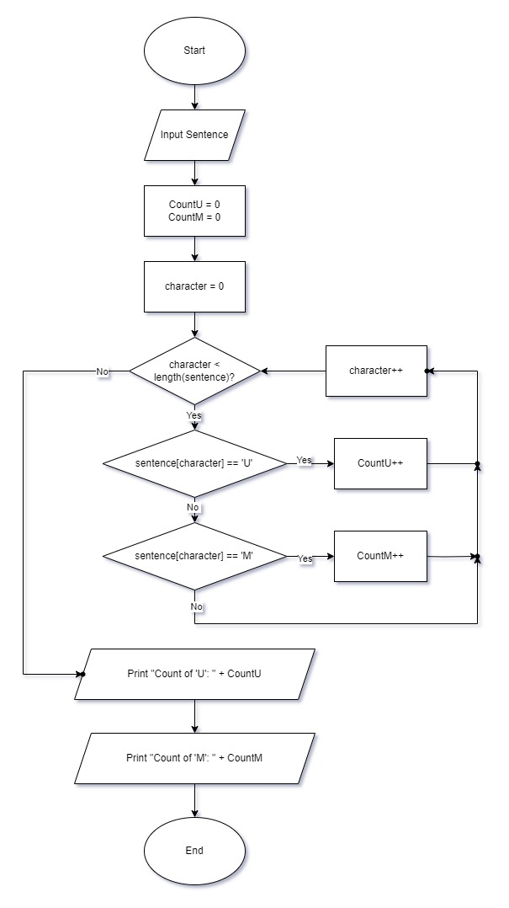

9. Display the Frequency of a Keyword in Web Page Content.

IPO
Input webpage content and keyword
Process: Count how many times keyword appears
Output: frequency

Pseudocode
1. Start
2. Input webPageContent
3. Input keyword
4. Initialise frequency = 0
5. For each word in webPageContent:
6. If word == keyword:
7. frequency++
8. Print "Frequency of '" + keyword + "': " + frequency
9. End

Flowchart
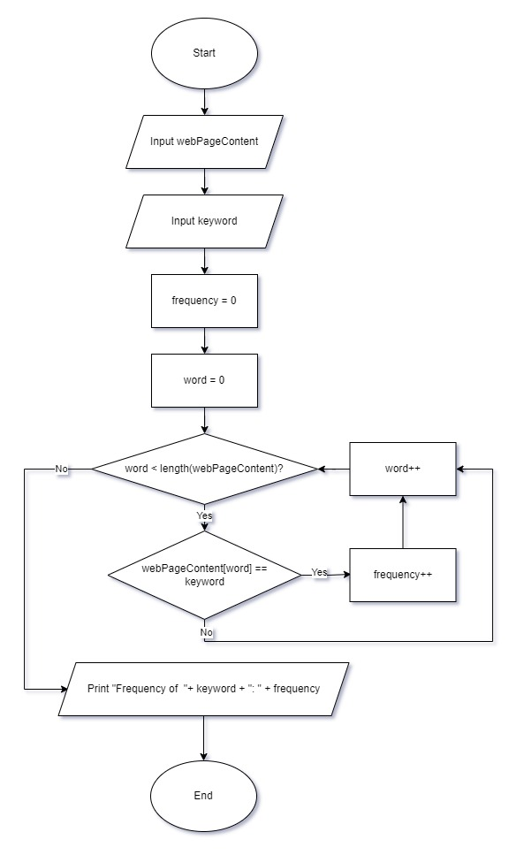

10. Display the Number of Female Students in a List.

IPO
Input: list
Process: Count ‘Female’
Output: freq.female

Pseudocode
1. Start
2. Input ListOfStudents (List of students' gender)
3. Initialise CountFemale = 0
4. For each student in ListOfStudents:
5. If student == 'Female':
6. CountFemale++
7. Print "Number of Female Students: " + CountFemale
8. End

Flowchart
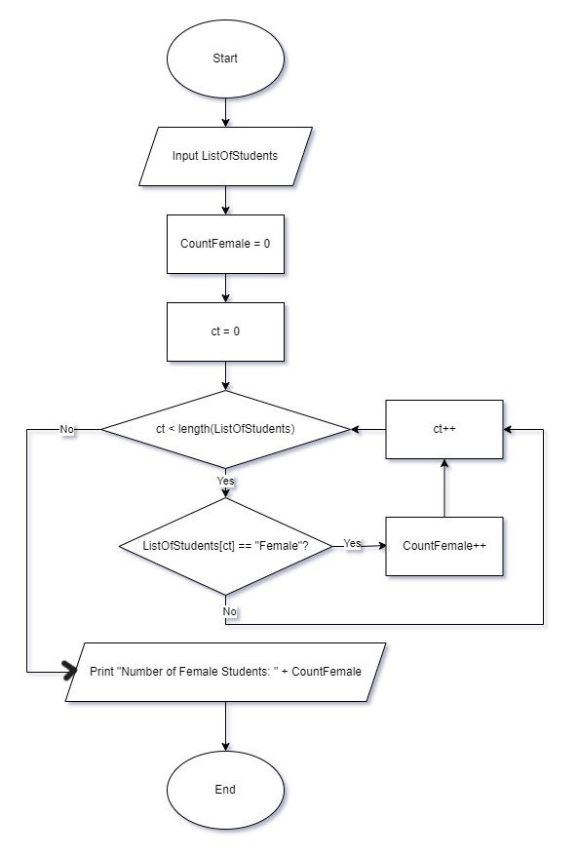

11. Display a List of 5 Random Numbers in Descending Order.

IPO
Input: Generate 5 random numbers
Process: Sort in descending order (bubble sort)
Output: sorted list.

Pseudocode
1. Start
2. Generate five random numbers
3. Sort the numbers in descending order (Bubble Sort)
4. Print the sorted numbers
5. End

Flowchart
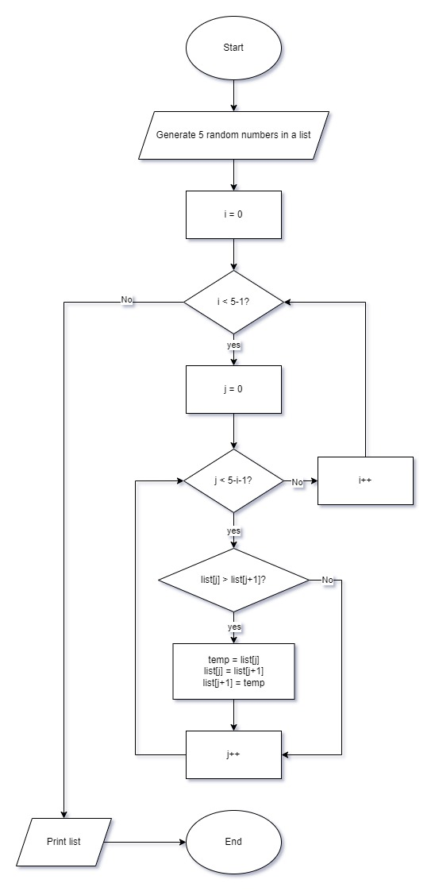

12. Guess a Random Number.

IPO
Input: Generate a random number and input user's guess
Process: Compare number and user’s guess
Output: hint or 'Correct'.

Pseudocode
1. Start
2. Generate RandomNumber
3. Input userGuess
4. If userGuess== RandomNumber
5. Print "Correct"
6. Else if userGuess < RandomNumber, then
7. Print "Too low"
8. Else
9. Print "Too high"
10. End

Flowchart
